**C U R R I C U L U M V I T A E**

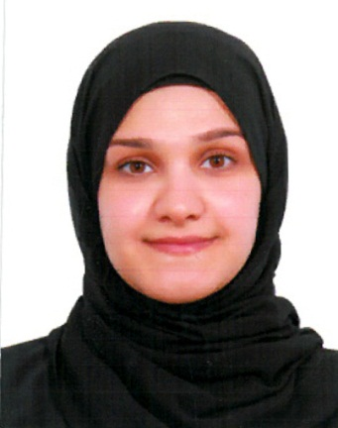

**Personal Information:**

**Name : Kawther Ali Alaiwi**

**Nationality : Bahraini**

**Gender : Female**

**Date of Birth : 20-05-1991**

**Marital Status : Married**

**Religion : Muslim**

**CPR No : 910507813**

**Address : Villa No: 229, Road 1505, Block 1215**

**Hamad Town, Kingdom of Bahrain**

**Telephone : +973-33682639, +973-17440031**

**Objective:**

**Seeking a suitable job according to my qualifications, skills and talents**

**Education Qualification**

* **Jan2014 University of Yarmouk**

**Bachelor degree in Accounting**

* **Jun 2009 Umaima Bint alnouman Secondary School**

**Secondary Certificate in commerce**

**Course Attended**

* **Sep 2017 Association of accounting technicians level one**
* **Aug 2015 Business English Course.**
* **Oct 2013 Management Skills Course.**

**Personal Skills:**

* **Active Teamwork and member with leadership capabilities.**
* **Hard working and able to work under pressure.**
* **Ability to articulate and communicate clearly and effectively at all levels.**
* **Good listener and communicator.**
* **Effective working on own initiative or as leader of a group.**
* **Research, evaluate and detailed qualitative & quantitative analysis.**
* **High computer literacy Microsoft office application(Word, Excel, power point)**

**Languages known**.

* **English ( Excellent )**
* **Arabic ( Mother tongue )**

**Reference**

**Available upon request**